Safety in the Science Classroom

**Examine the picture of the laboratory. Can you identify 10 hazards?**

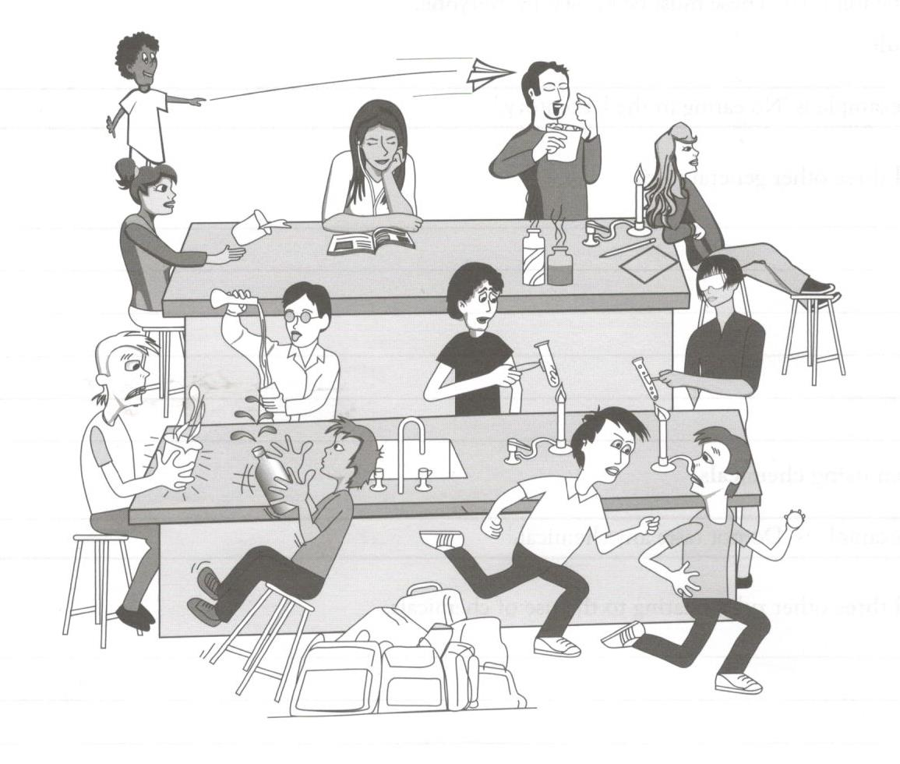

1. _____________________________________________________________________________
2. _____________________________________________________________________________
3. _____________________________________________________________________________
4. _____________________________________________________________________________
5. _____________________________________________________________________________
6. _____________________________________________________________________________
7. _____________________________________________________________________________
8. _____________________________________________________________________________
9. _____________________________________________________________________________
10. _____________________________________________________________________________

**Answer the following questions.**

1. For 6 of the hazards you found in the picture, write a safety rule for the Science classroom.




7. State whether the following rules are good ones or silly ones likely to cause injury. Rewrite the silly ones so that they are sensible rules.
   1. Running and pushing people in the laboratory is never allowed.
   2. It is alright to eat and drink in the laboratory.
   3. Spilt chemicals can be left unattended.
   4. The teacher must always be told if something goes wrong.
   5. Safety glasses are optional when we use chemicals in the laboratory.
   6. Always point test tubes away from yourself and others.
8. Why must you tie back long hair and not lean over a Bunsen burner while it is lit?

**For each of the safety scenarios below, identify the unsafe practice(s) and how it should be corrected to make the situation safe.**

**Safety Scenario 1**

The teacher was not in the room yet. Jake began to get out equipment and weigh chemicals for his experiment.

**Safety Scenario 2**

Alex lit the Bunsen burner then stretched across the flame to pass Mary a beaker.

**Safety Scenario 3**

Sam was heating a test tube. He didn’t put on his safety glasses. He tilted the test tube away from his work area, but towards student working at another lab station.

**Safety Scenario 4**

Cindy broke a test tube. Carefully she picked up the pieces with one hand and placed them in her other hand. Then she put the pieces of glass in the rubbish bin.

**Safety Scenario 5**

While Chris was cleaning up, he noticed a small crack in a test tube. Afraid he would be blamed for breaking it, he put it away anyway.

**Safety Scenario 6**

Matt and Sally completed their lab work early so they decided to perform their own experiments with their left over chemicals.

**Safety Scenario 7**

Amy was away when the investigation was discussed. She gathered her materials and watched her classmates to see what to do, not reading the instructions.

**Safety Scenario 8**

Terry was observing a sample of a substance. He noticed it had a sweet smell. He decided to dip his finger in it to check its taste.

**Safety Scenario 9**

Lara finished the lab just at the end of class and was in a hurry to get to her next class. She knew that lunch was in an hour, but she decided to wash her hands later.

**Safety Scenario 10**

John arrived at the lab just after recess with his unfinished packet of biscuits in his pocket. He begins his experiment and while he is working, finished his biscuits.